***WT LAB PRACTICAL***

*PARAS YADAV*

*BCA AIML*

*105*

Q1. create a html page using basic tags.

INPUT :- <html>

<head>

<title> my first html page </title>

</head>

<body>

<h1>"hello world"</h1>

</body>

</html>

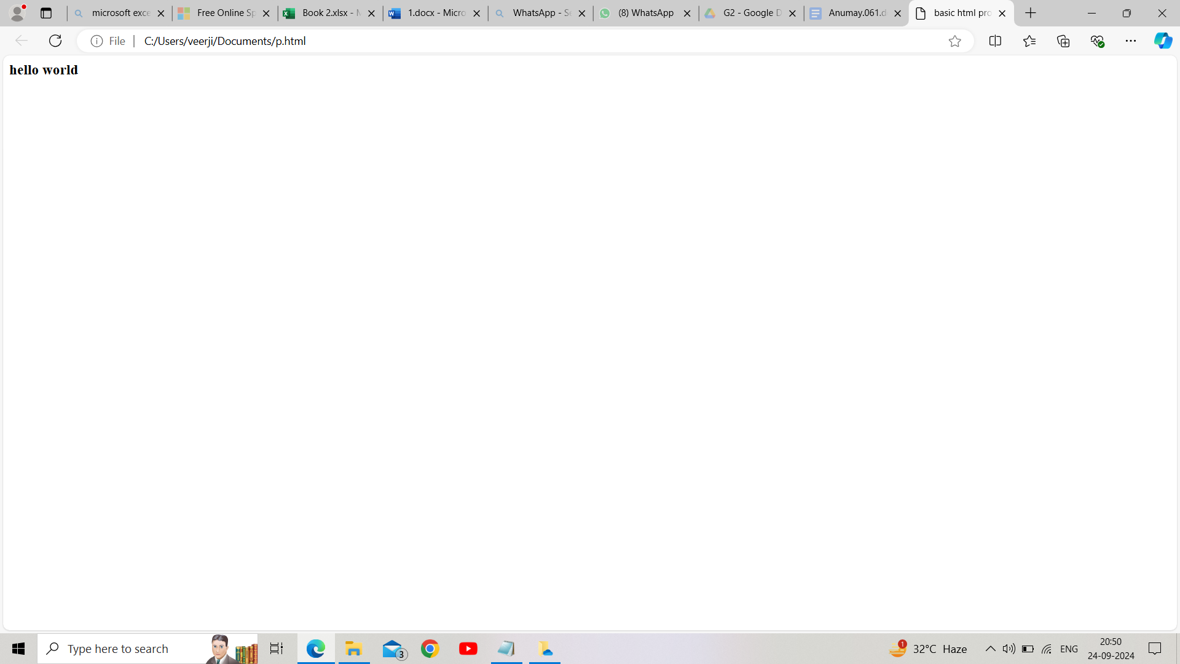

Q2. create a page that displays your name to the screen.

INPUT- <HTML>

<head>

<title> my first html page </title>

</head>

<body>

<h1>"paras yadav"</h1>

</body>

</html>

OUTPUT

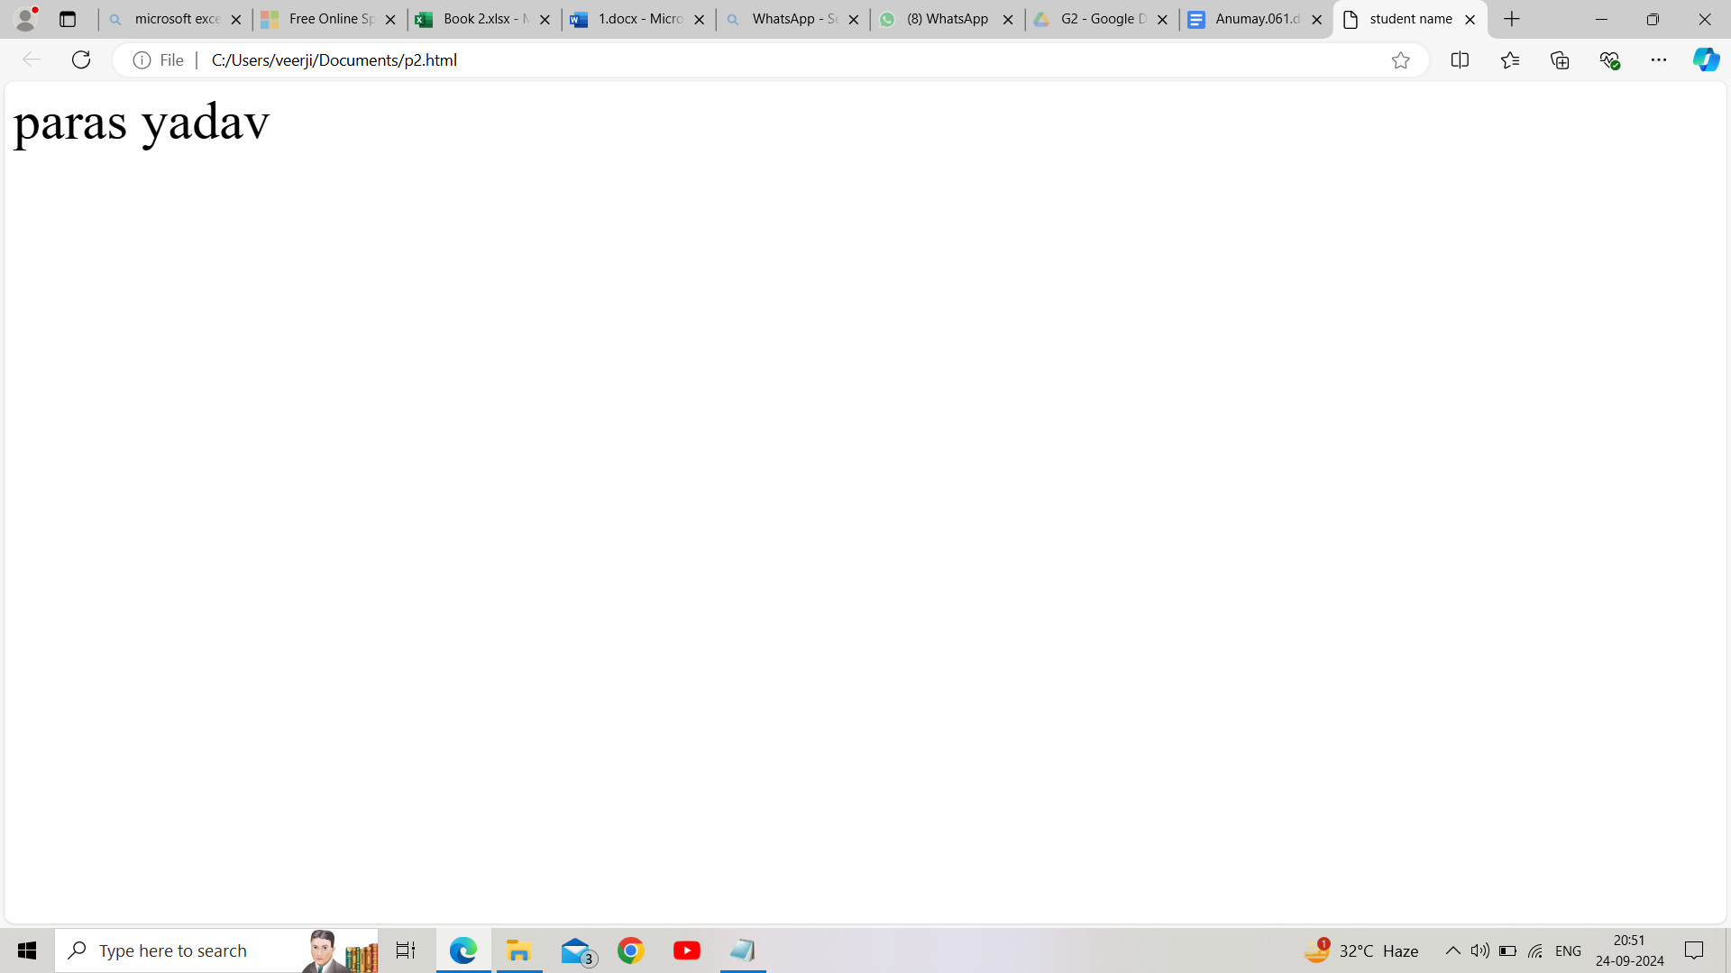Q3. create a webpage and show the output from 1 to 10 in separate lines. INPUT- <html>

<head>

<title>Numbers 1 to 10</title>

</head>

<body>

1<br>

2<br>

3<br>

4<br>

5<br>

6<br>

7<br>

8<br>

9<br>

10

</body>

</html>

OUTPUT

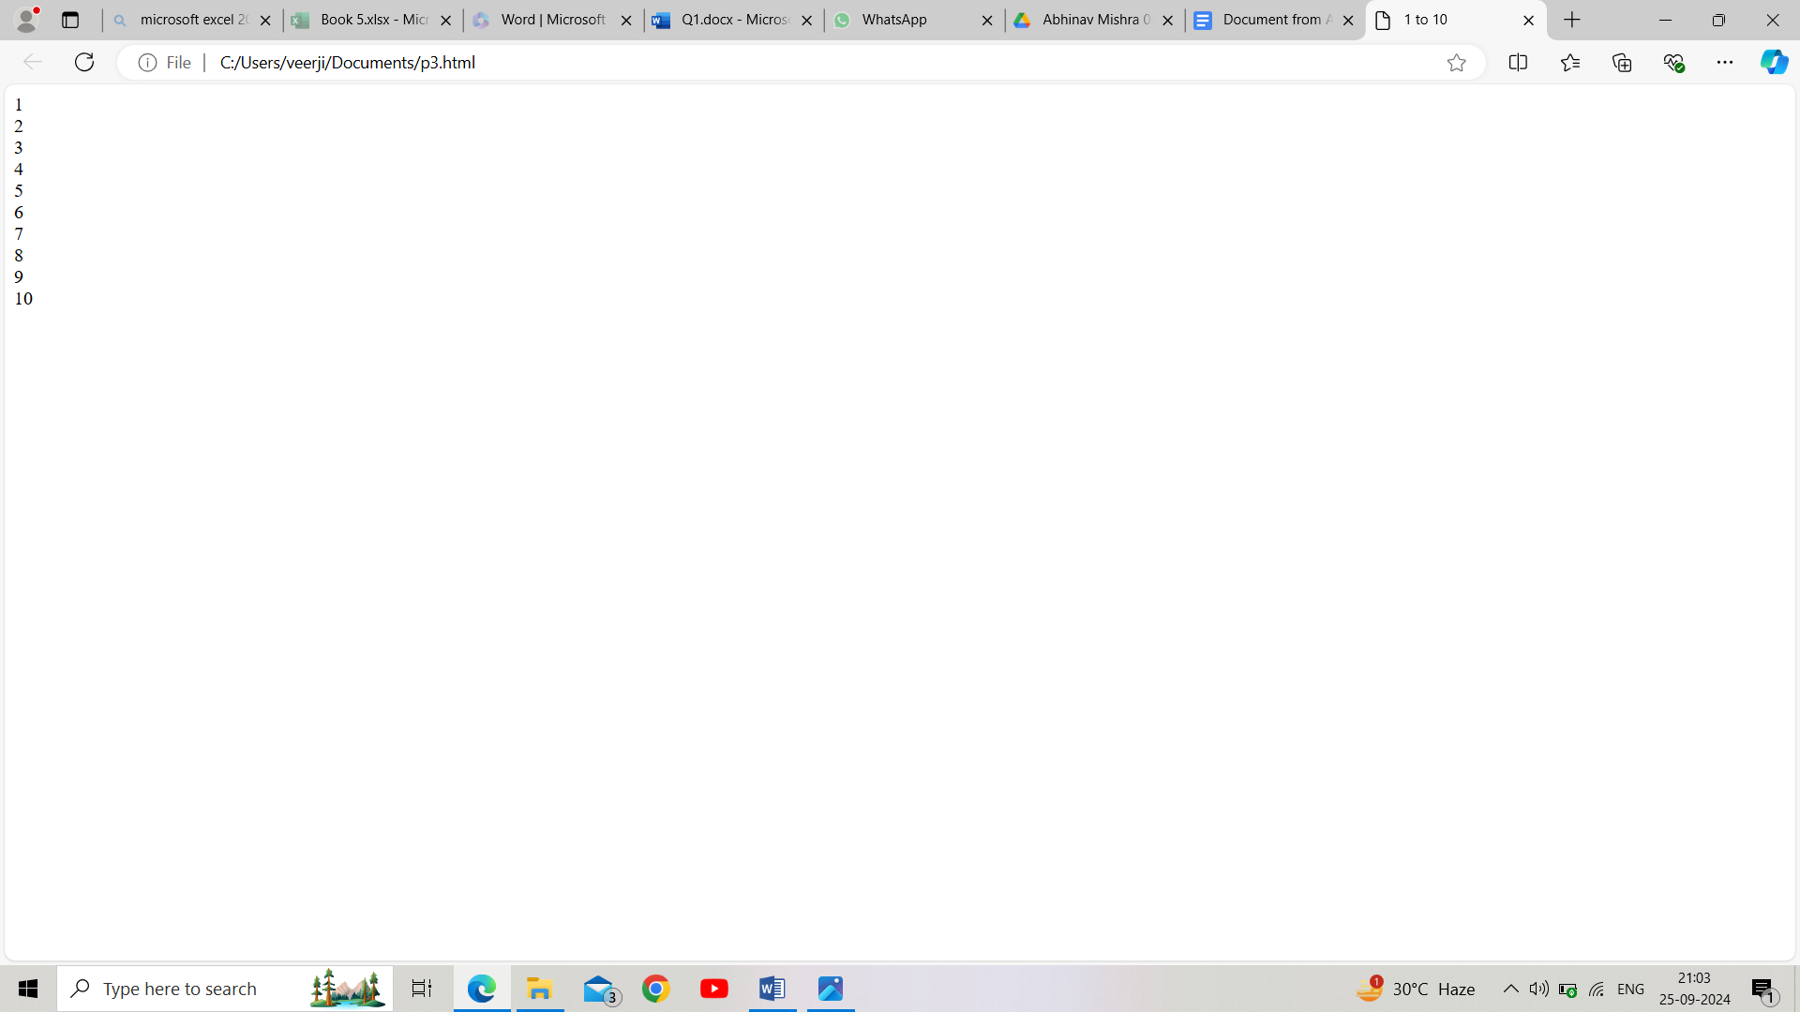**Q4.** Create a web page and show the output from 1 to 10 in separate lines.

Each number being in different colour.

*Input:*

<html>

<head>

<title>1 to 10 in different colour</title>

</head>

<body>

<font color = "red"> 1 </font><br>

<font color = #87CEEB > 2 </font><br>

<font color = "orange"> 3 </font><br>

<font color = "pink"> 4 </font><br>

<font color = "green"> 5 </font><br>

<font color = "yellow"> 6 </font><br>

<font color = "black"> 7 </font><br>

<font color = "brown"> 8 </font><br>

<font color = "violet"> 9 </font><br>

<font color = #808080>10 </font>

</body>

</html>

*Output:*

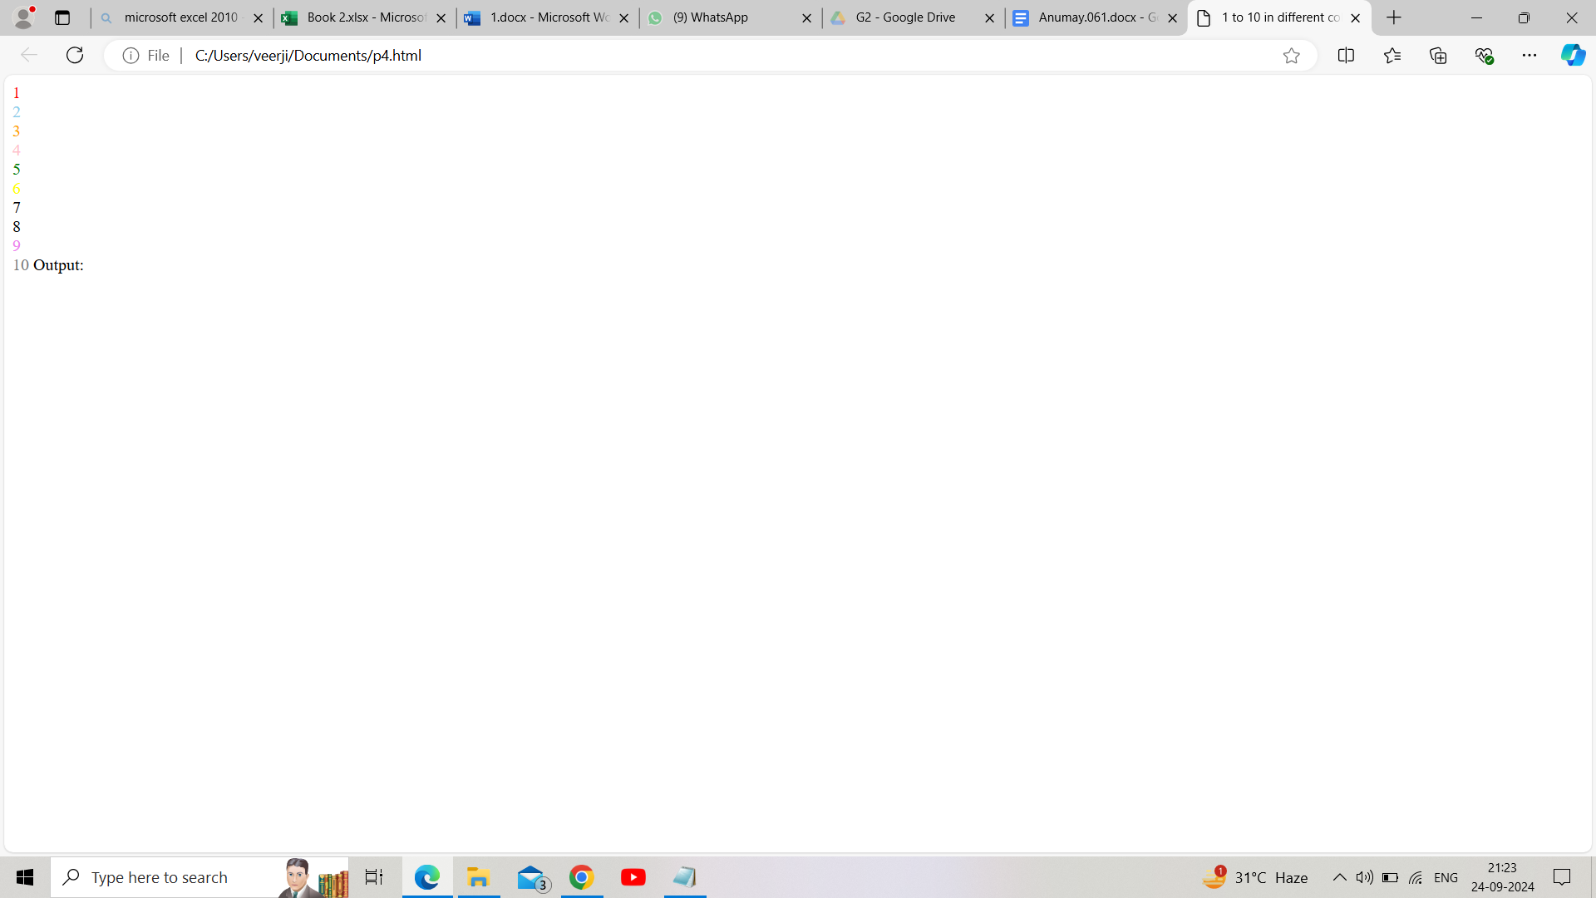

**Q5.** How do I make a picture as a background on my web page?

*Input:*

<html>

<head>

<title>image as a background</title>

</head>

<body background= "C:\Users\HP\Downloads\ms dhoni.jpg">

</body>

</html>

*Output:*

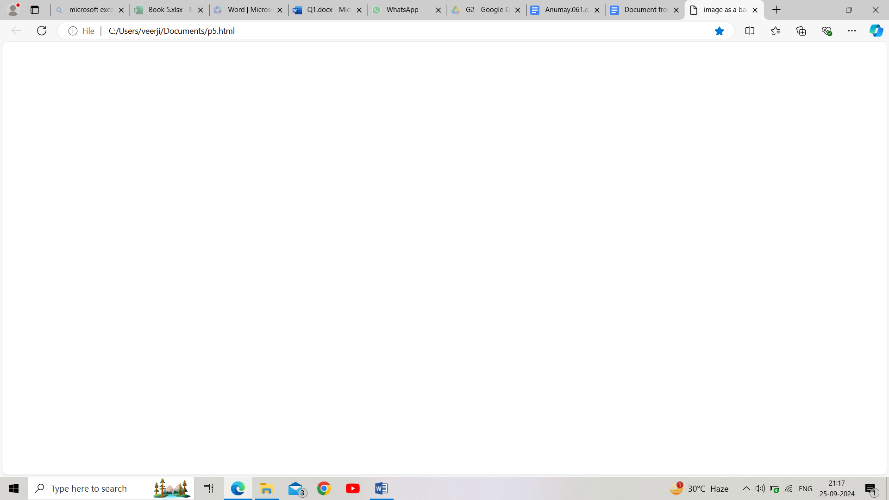

**Q6.** Create a web page to print a paragraph with 4-5 sentences, each sentence shall have a different font.

*Input:*

<html>

<head>

<title>paragraph with different font</title>

</head>

<body>

<p><font face= "Agency FB"> A car is a means of transport used for travelling from one place to another.</font><font face= "Comic Sans MS"> This is a four-wheeler used by individuals or family members.</font><font face="Bradley Hand ITC"> We all use cars in our daily lives to go from one place to another for work.</font><font face= "Cascadia Code SemiLight"> A car is a beautiful vehicle that has comfortable seats, AC, and windows.</font></p>

</body>

</html>

*Output:*

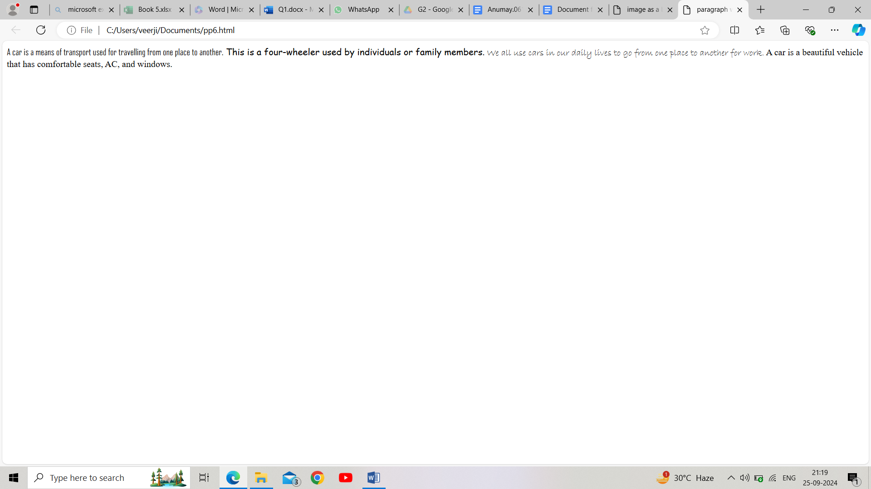**Q7.** Write a html code to print a paragraph that is description of a book**,** it shall include the title of the book, its author name; name and title should be underlined and all adjectives shall be **bold** and *italics.*

*Input:*

<html>

<head>

<title>Book Description</title>

</head>

<body>

<h1><u><B>The Great Gatsby</u></B></h1>

<p>AUTHOR NAME:<u>F.Scott Fitzgerald</u><br>

The Great Gatsby is a <B>classic novel</B> set in the <i>roaring</i> 1920s. It explores the <B>glamorous</B> and <B>decadent</B> lifestyles of the era through the eyes of the <i>mysterious</i >and wealthy Jay Gatsby. The story delves into themes of <B>unrequited love</B>, moral decay, and the <i>elusive nature</i> of the American Dream.</p>

</body>

</html>

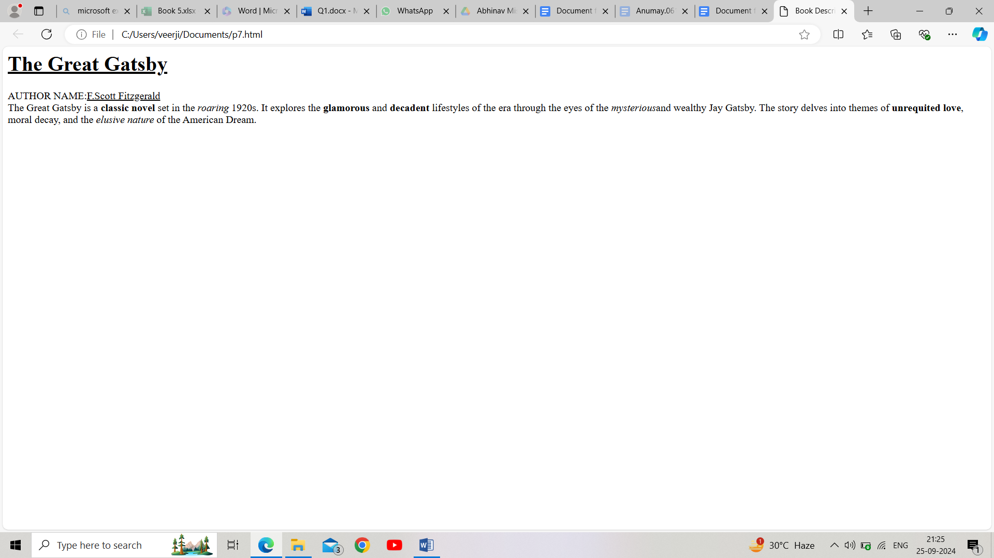**Q8.** Write html code to print your name using heading tag, every letter should be of different heading size.

*Input:*

<html>

<head>

</head>

<body>

<h1>P</h1>

<h2>A</h2>

<h3>R<h3>

<h4>A</h4>

<h5>S</h5>

<h6>Y</h6>

</body>

</html>

*Output:*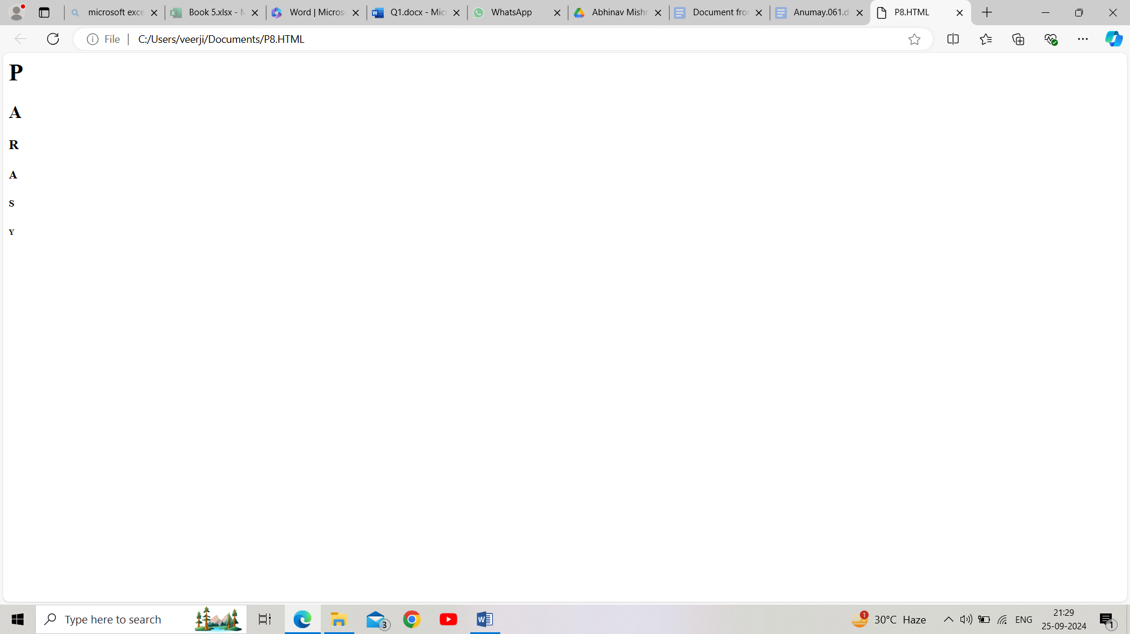**Q9.** Write html code to print the sequence of number 1-20. Each number shall be in a different line with number 2 next to it as subscript, an equal sign and the result.

<html>

<head>

</head>

<body>

1<sub>2</sub>=1<br>

2<sub>2</sub>=4<br>

3<sub>2</sub>=9<br>

4<sub>2</sub>=16<br>

5<sub>2</sub>=25<br>

6<sub>2</sub>=36<br>

7<sub>2</sub>=49<br>

8<sub>2</sub>=64<br>

9<sub>2</sub>=81<br>

10<sub>2</sub>=100

</body>

</html>

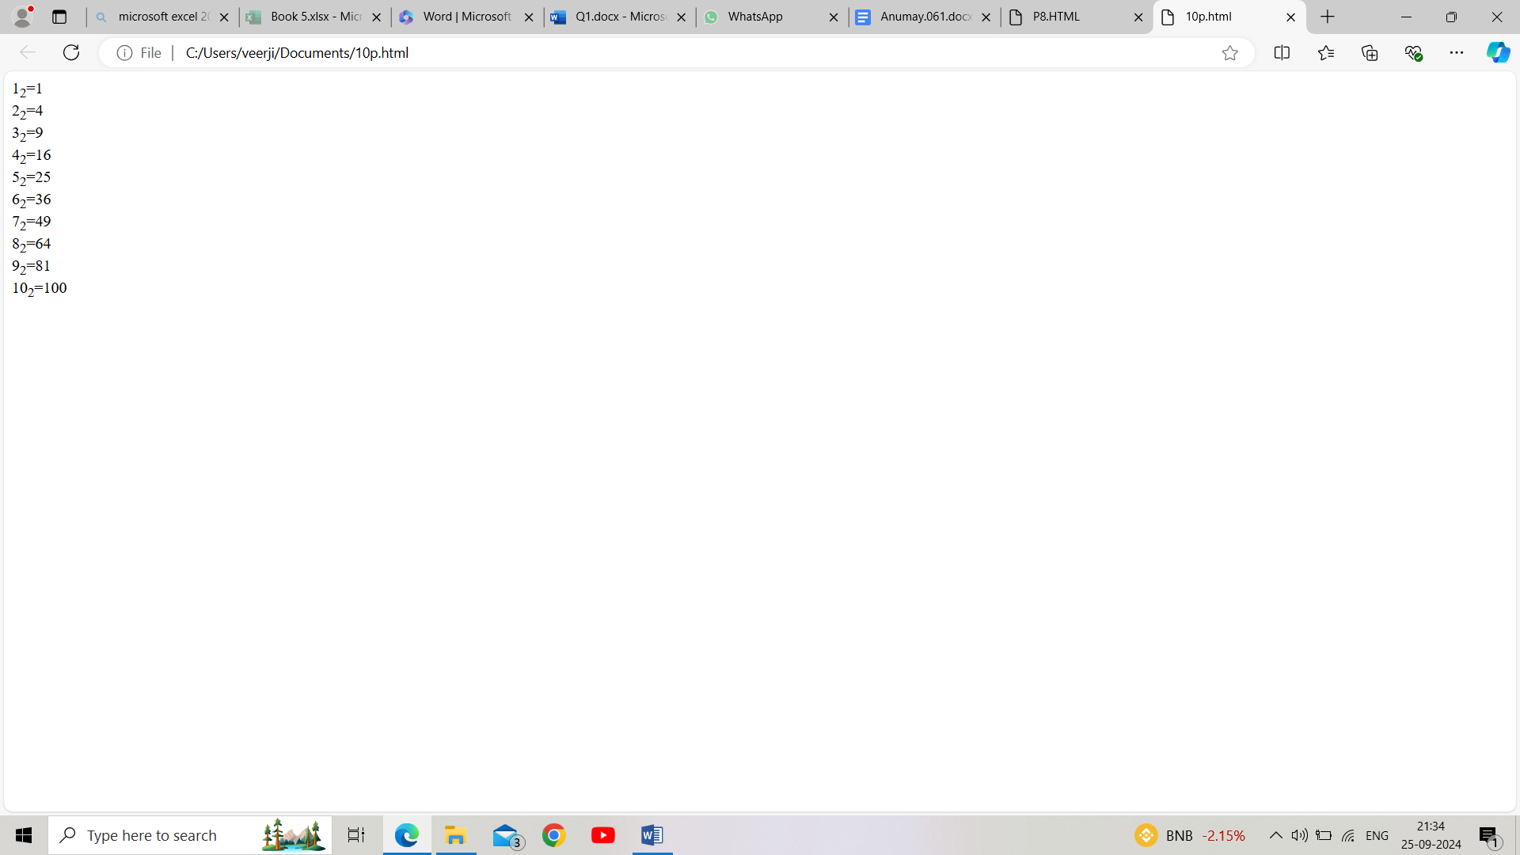

**Q10.** Write a html code to display an image with border of size with width 200 height 200 pixels ,leaving Hspace and Vspace of your choice with image hanging in the right side on the screen.

*Input:*

<html>

<head>

</head>

<body>

<img src="C:\Users\HP\Downloads\img.jpg", width="200",height="400",align="left", border="5", hspace="50", vspace="80">

</body>

</html>

*Output:*

**Q11.**Write a html code to create a web page with heading. the heading shall be displayed at the top-center of the page and the image shall be at the center , just below the heading

*Input:*

<html>

<head>

</head>

<body>

<h2><center> Chamelion </center></h2>

<center><img src="C:\Users\HP\Downloads\img.jpg", width="200",height="200"></center>

</body>

</html>

*Output:*